Captain James C. Estramonte
Chief of Staff, Pacific Area
U.S. Coast Guard

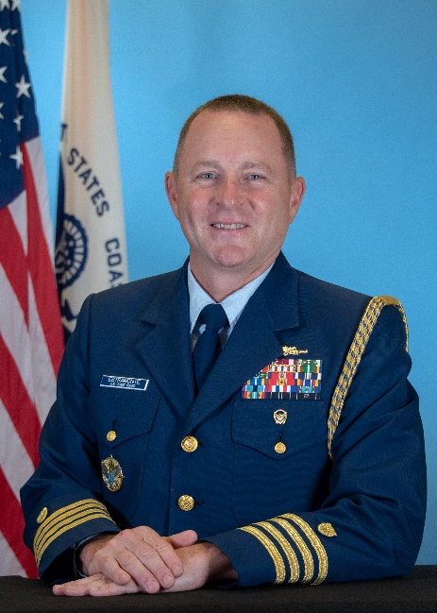
Captain Estramonte assumed the duties of Chief of Staff to the Commander, Pacific Area in May 2020. He is originally from Greenwich, NY and graduated from the Coast Guard Academy in 1993 with a Bachelor of Science in Management.

Following graduation, he was assigned aboard CGC RUSH in Honolulu, HI, as a Deck Watch Officer and Law Enforcement Boarding Officer. From there, he was assigned to the Seventh District Maritime Intelligence Center, in Miami, FL, where he worked as Watch Officer and Post-Seizure Collections Officer.

In 1999, he served as Executive Officer of Tactical Law Enforcement Team South, Miami, FL, where he supervised 9 Law Enforcement Detachments and 2 Deployable Pursuit Boat teams.
CAPT Estramonte returned to sea as Operations Officer aboard CGC CHASE, San Diego, CA, where he was in charge of tactical and strategic deployment of the cutter and led a 60 person department. From there, he was selected to the Coast Guard's Financial Management Program and attended George Mason's School of Management, Fairfax, VA. Upon completion of his Master’s in Business Administration, he was assigned to Coast Guard Headquarters, CG-832, the Financial Analysis division of the Assistant Commandant for Resources.
In 2009, CAPT Estramonte once again returned to sea, and once again returned to serve aboard CGC RUSH, this time as Executive Officer. In 2011, he was selected to serve as Commanding Officer of CGC VIGILANT, Cape Canaveral, FL.
In 2013, CAPT Estramonte returned to Washington, DC as the Military Assistant to the Secretary of Homeland Security, the Honorable Jeh C. Johnson. In 2015, he served a year as a Senior Military Fellow at the Center for a New American Security (CNAS) in Washington, DC. His next assignment, from 2016-2018, was at Coast Guard Headquarters as CG-83, the Chief of Office of Resource Management, where he oversaw the current year execution of the Coast Guard’s budget.

CAPT Estramonte recently commanded CGC MUNRO, Alameda, CA, from 2018-2020. He patrolled throughout the Pacific Area AOR, including Oceania, where MUNRO visited Guadalcanal, where Signalman 1/C Douglas Munro gave his life saving a group of Marines. MUNRO also patrolled off the coast of Central and South America, combatting illegal drug flow, notably making the Coast Guard’s largest bust in 5 years aboard a Self-Propelled Semi-Submersible where Go-Pro video went viral. The seizure netted almost 8 tons of cocaine.
CAPT Estramonte's personal awards include the Legion of Merit, Meritorious Service Medals (five), the Coast Guard Commendation Medal (four), the 9-11 Medal and various service and unit awards.
CAPT Estramonte has been married to his wife, Luz, for 22 years and has two children, Marissa (16) and Bella (15). They reside in Bay Farm, Alameda.

